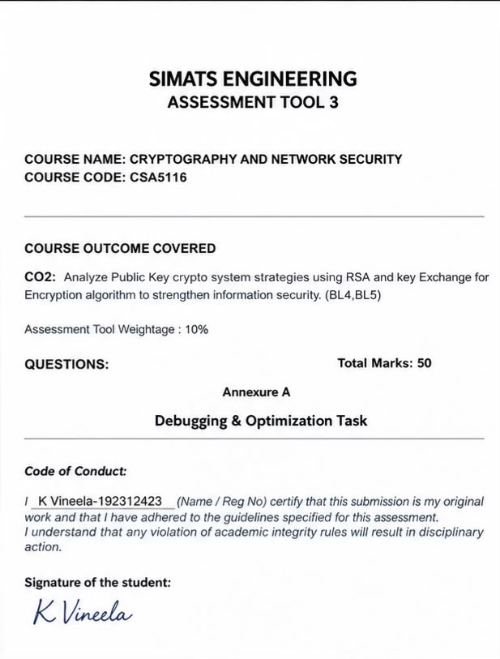

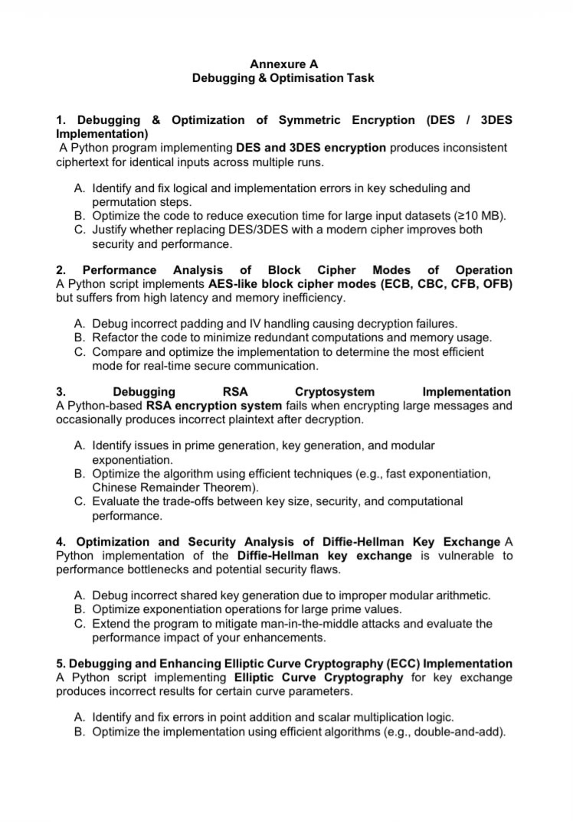
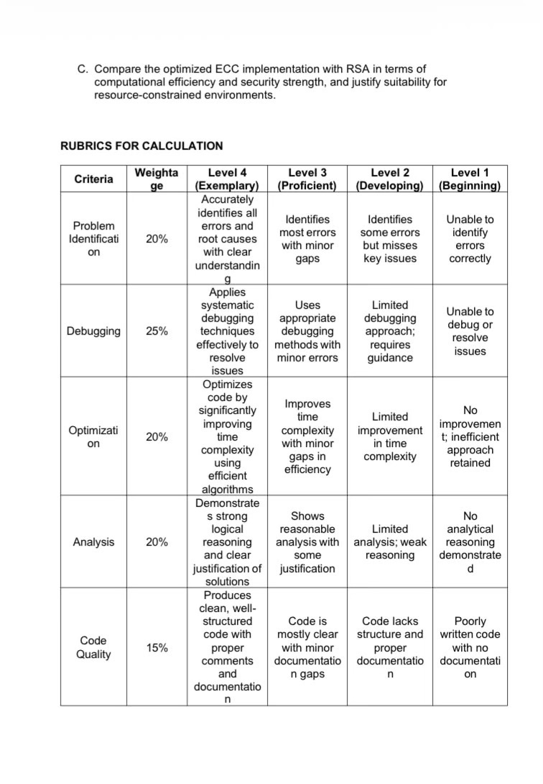
2.Performance Analysis of Block Cipher Modes of Operation
1. Introduction
Cryptography is an essential part of information security that protects sensitive data from unauthorized access. Block ciphers are widely used to encrypt information transmitted over computer networks, stored in databases, and exchanged between applications.
A block cipher encrypts data in fixed-size blocks using a secret key. However, when a message is longer than one block, a mode of operation is required to determine how the blocks are processed.
Advanced Encryption Standard (AES) is one of the most widely used symmetric encryption algorithms. Different AES modes, such as Electronic Codebook (ECB), Cipher Block Chaining (CBC), Cipher Feedback (CFB), and Output Feedback (OFB), provide different performance characteristics and security properties.
A Python implementation that uses these modes may suffer from high latency, excessive memory usage, incorrect padding, and invalid Initialization Vector (IV) handling. Therefore, analyzing and optimizing these implementations is important for developing efficient and secure communication systems.
This project evaluates the working, performance, limitations, and security of different block cipher modes and identifies a suitable approach for real-time secure communication.
2. Objectives
- To understand the working principles of AES and block cipher modes.
- To study ECB, CBC, CFB, and OFB encryption techniques.
- To identify and correct padding and IV-handling errors.
- To optimize Python code by reducing redundant computations and memory copies.
- To measure encryption latency, throughput, and memory consumption.
- To compare the performance of different encryption modes.
- To identify a suitable mode for real-time secure communication.
- To maintain data confidentiality and integrity without sacrificing unnecessary performance.
3. Problem Statement
A Python script implements AES-like block cipher modes, including ECB, CBC, CFB, and OFB. However, the implementation suffers from high latency, inefficient memory usage, and decryption failures.
These problems may result from incorrect padding, invalid IV handling, repeated data conversions, unnecessary memory allocation, and inefficient processing loops.
The project aims to debug these issues, optimize the implementation, compare the performance of different modes, and recommend an efficient and secure encryption approach for real-time communication.
4. Overview of AES
AES stands for Advanced Encryption Standard. It is a symmetric-key encryption algorithm in which the same secret key is used for encryption and decryption.
AES supports three key sizes:
- AES-128: 128-bit key.
- AES-192: 192-bit key.
- AES-256: 256-bit key.
AES processes data in fixed-size blocks of 128 bits, or 16 bytes, regardless of the selected key size.
Working of AES
- The original message is represented as plaintext.
- The plaintext is processed by the AES encryption algorithm using a secret key.
- The resulting ciphertext is transmitted or stored.
- The receiver uses the corresponding secret key to decrypt the ciphertext.
- The original plaintext is recovered.
AES uses several internal transformations, including SubBytes, ShiftRows, MixColumns, and AddRoundKey.
The AES algorithm processes individual blocks, while the mode of operation determines how multiple blocks are handled.
5. Block Cipher Modes of Operation
5.1 Electronic Codebook (ECB)
ECB is the simplest block cipher mode. Each plaintext block is encrypted independently using the same secret key.
Working:
- Divide the plaintext into blocks.
- Encrypt each block independently.
- Combine the encrypted blocks to obtain ciphertext.
- Decrypt each block independently at the receiving end.
Advantages:
- Simple to implement.
- Supports parallel encryption and decryption.
- Does not require an IV.
Disadvantages:
- Identical plaintext blocks produce identical ciphertext blocks.
- Patterns in the original data may remain visible.
- Does not provide authentication or integrity protection.
Application: ECB is useful for limited demonstrations and certain specialized cases involving independent blocks, but it is not recommended for general confidential messages.
5.2 Cipher Block Chaining (CBC)
CBC combines each plaintext block with the previous ciphertext block using XOR before encryption. The first block uses an IV.
Working:
- Generate an appropriate IV.
- Combine the first plaintext block with the IV using XOR.
- Encrypt the result using AES.
- Combine each subsequent plaintext block with the previous ciphertext block.
- Continue until the message is encrypted.
Advantages:
- Reduces direct pattern leakage compared with ECB.
- Can be used in legacy encryption systems.
- Supports parallel decryption of ciphertext blocks.
Disadvantages:
- Encryption is sequential.
- Padding is required when the message length is not a multiple of the block size.
- Does not provide authentication by itself.
Application: CBC can be used in systems that require it and implement secure IV handling and message authentication.
5.3 Cipher Feedback (CFB)
CFB converts a block cipher into a feedback-based, stream-like encryption mode. It uses the block cipher's output and previous ciphertext to process data.
Working:
- Initialize the mode with an IV.
- Encrypt the feedback value.
- Combine the generated output with the plaintext using XOR.
- Feed the appropriate ciphertext segment into the next operation.
- Repeat until the entire message is processed.
Advantages:
- Does not require block padding.
- Can process data that is not a multiple of the AES block size.
- Supports certain streaming applications.
Disadvantages:
- Encryption is sequential.
- Transmission errors can affect subsequent processing temporarily.
- Does not provide authentication.
Application: CFB may be found in legacy systems that require stream-like processing.
5.4 Output Feedback (OFB)
OFB generates a keystream by repeatedly encrypting an internal feedback value. The generated keystream is combined with the plaintext using XOR.
Working:
- Initialize the process with an IV.
- Encrypt the IV to generate the first keystream block.
- Combine the keystream with the plaintext using XOR.
- Encrypt the previous output to generate the next keystream block.
- Repeat until the message is processed.
Advantages:
- Does not require padding.
- Transmission errors do not propagate through the decryption process in the same way as CBC errors.
- Keystream generation is independent of the plaintext.
Disadvantages:
- Keystream generation is sequential.
- Reusing the same key and IV can seriously compromise confidentiality.
- Does not provide authentication.
Application: OFB can be used in specialized or legacy systems that require stream-like encryption.
6. Comparison of ECB, CBC, CFB, and OFB
Feature | ECB | CBC | CFB | OFB
Full form | Electronic Codebook | Cipher Block Chaining | Cipher Feedback | Output Feedback
IV required | No | Yes | Yes | Yes
Padding required | Yes | Yes | No | No
Encryption parallelism | Yes | No | No | Keystream is sequential
Pattern leakage | High risk | Reduced | Reduced | Reduced
Error propagation | Affects corresponding block | Can affect two adjacent plaintext blocks | Depends on segment size | Bit errors generally affect corresponding plaintext bits
Authentication | No | No | No | No
General suitability | Not recommended for sensitive messages | Legacy systems | Legacy streaming systems | Specialized systems

The actual performance of each mode depends on the cryptographic library, hardware acceleration, message size, and implementation.
7. Common Implementation Problems

7.1 Incorrect Padding
AES uses a block size of 16 bytes. ECB and CBC require input data to be a multiple of the block size.
If the input does not meet this requirement, encryption may fail or decryption may produce errors.
Solution: Apply PKCS#7 padding before ECB or CBC encryption and remove the padding after decryption. CFB and OFB do not require block padding.
7.2 Incorrect IV Handling
CBC, CFB, and OFB require a valid 16-byte IV when used with AES.
Using an invalid IV length or the wrong IV during decryption can cause errors or incorrect output.
Solution: Generate a fresh, appropriately random IV for each encryption operation and transmit or store it with the ciphertext. The receiver must use the corresponding IV.
7.3 Redundant Computations
Repeated conversions, unnecessary calculations, and repeated data processing can increase latency.
Solution: Use byte-oriented data, avoid unnecessary conversions, and rely on optimized cryptographic libraries.
7.4 Excessive Memory Usage
Repeatedly concatenating large buffers or maintaining multiple unnecessary copies of plaintext and ciphertext can increase memory consumption.
Solution: Minimize intermediate buffers and use chunk-based processing for large messages when supported by the implementation.
7.5 Incorrect Encryption and Decryption Parameters
Encryption and decryption must use matching keys, modes, IVs, and padding rules.
Solution: Validate the parameters and perform round-trip testing to verify that decrypted data matches the original plaintext.
8. Proposed System
The proposed system uses an optimized Python implementation to compare ECB, CBC, CFB, and OFB.
The system accepts input data, encrypts it using the selected mode, measures the processing time and memory consumption, and decrypts the resulting ciphertext to verify correctness.
Main components
- Input Module: Accepts text or test data.
- Encryption Module: Encrypts the input using the selected AES mode.
- IV and Padding Management Module: Handles IV generation and padding according to the selected mode.
- Decryption Module: Recovers the original plaintext.
- Performance Measurement Module: Measures latency, throughput, and memory usage.
- Comparison Module: Compares results across the modes.
- Result Module: Displays performance measurements and identifies potential optimizations.
System workflow
Input Data → Select AES Mode → Manage IV and Padding → Encrypt Data → Measure Performance → Decrypt Data → Verify Correctness → Compare Results
9. Python Implementation
The following program uses PyCryptodome to implement and benchmark the four modes using actual AES.
Install the required library:
python3 -m pip install pycryptodome
import os
import time
import tracemalloc
from Crypto.Cipher import AES
from Crypto.Util.Padding import pad, unpad

BLOCK_SIZE = AES.block_size
KEY = os.urandom(32) # AES-256 key

def encrypt(data, mode):
if mode == "ECB":
cipher = AES.new(KEY, AES.MODE_ECB)
return cipher.encrypt(pad(data, BLOCK_SIZE)), None

iv = os.urandom(BLOCK_SIZE)

if mode == "CBC":
cipher = AES.new(KEY, AES.MODE_CBC, iv=iv)
ciphertext = cipher.encrypt(pad(data, BLOCK_SIZE))

elif mode == "CFB":
cipher = AES.new(
KEY, AES.MODE_CFB, iv=iv, segment_size=128
)
ciphertext = cipher.encrypt(data)

elif mode == "OFB":
cipher = AES.new(KEY, AES.MODE_OFB, iv=iv)
ciphertext = cipher.encrypt(data)

else:
raise ValueError("Unsupported mode")

return ciphertext, iv

def decrypt(ciphertext, mode, iv=None):
if mode == "ECB":
cipher = AES.new(KEY, AES.MODE_ECB)
return unpad(cipher.decrypt(ciphertext), BLOCK_SIZE)

if iv is None or len(iv) != BLOCK_SIZE:
raise ValueError("A valid 16-byte IV is required")

if mode == "CBC":
cipher = AES.new(KEY, AES.MODE_CBC, iv=iv)
return unpad(cipher.decrypt(ciphertext), BLOCK_SIZE)

if mode == "CFB":
cipher = AES.new(
KEY, AES.MODE_CFB, iv=iv, segment_size=128
)
return cipher.decrypt(ciphertext)

if mode == "OFB":
cipher = AES.new(KEY, AES.MODE_OFB, iv=iv)
return cipher.decrypt(ciphertext)

raise ValueError("Unsupported mode")

def benchmark(data, mode, repeats=5):
times = []
tracemalloc.start()

for _ in range(repeats):
start = time.perf_counter()
ciphertext, iv = encrypt(data, mode)
times.append(time.perf_counter() - start)

_, peak_memory = tracemalloc.get_traced_memory()
tracemalloc.stop()

average_time = sum(times) / len(times)
throughput = len(data) / average_time / (1024 * 1024)

recovered = decrypt(ciphertext, mode, iv)
assert recovered == data, "Verification failed"

return (
average_time * 1000,
throughput,
peak_memory / 1024
)

if __name__ == "__main__":
test_data = b"Financial transaction data: " * 1000

for mode in ("ECB", "CBC", "CFB", "OFB"):
ciphertext, iv = encrypt(test_data, mode)
assert decrypt(ciphertext, mode, iv) == test_data
print(f"{mode}: encryption/decryption successful")

data = os.urandom(1024 * 1024)

print("\nPerformance Results")
print("-" * 65)
print(f"{'Mode':<8}{'Latency (ms)':>15}"
f"{'Throughput (MiB/s)':>22}"
f"{'Peak memory (KiB)':>20}")

for mode in ("ECB", "CBC", "CFB", "OFB"):
latency, throughput, memory = benchmark(data, mode)
print(f"{mode:<8}{latency:>15.2f}"
f"{throughput:>22.2f}{memory:>20.2f}")
Note: This program is intended for educational benchmarking. ECB is included for comparison only and should not be used for confidential multi-block messages. CBC, CFB, and OFB do not provide integrity protection. Modern applications should generally use authenticated encryption such as AES-GCM.
10. Explanation of the Python Program
- The program imports AES, padding utilities, timing functions, and memory measurement tools.
- A 256-bit AES key is generated for the test.
- The encrypt() function encrypts input data using the selected mode.
- The decrypt() function reverses the encryption operation using the matching parameters.
- Padding is applied only to ECB and CBC.
- CBC, CFB, and OFB use a fresh IV for each encryption operation.
- The benchmark() function measures average encryption latency, estimated throughput, and peak traced Python memory.
- The program decrypts the ciphertext and checks that the recovered data matches the original input.
- Finally, it displays the measurements for each mode.
The reported memory usage is traced Python memory, not total process memory. The benchmark is a starting point; more rigorous experiments should include warm-up runs, repeated trials, and separate encryption and decryption measurements.
11. Performance Metrics
11.1 Latency
Latency is the time required to complete an operation.
Latency = Completion Time − Start Time
Lower latency is desirable for real-time communication.
11.2 Throughput
Throughput measures the amount of data processed per unit of time.
Throughput = Data Processed / Elapsed Time
Higher throughput is desirable for large files and high-volume network traffic.
11.3 Memory Consumption
Memory consumption represents the resources used to store input data, ciphertext, IVs, keys, and temporary buffers.
Reducing unnecessary copies and intermediate buffers can improve memory efficiency.
11.4 CPU Utilization
CPU utilization measures the processing resources consumed by encryption and decryption. High CPU utilization may reduce the resources available for other applications.
12. Performance Optimization Techniques
- Use optimized cryptographic libraries instead of implementing AES manually.
- Avoid unnecessary string-to-byte conversions.
- Reduce repeated memory allocation and buffer copying.
- Process large messages in manageable chunks where supported.
- Measure encryption and decryption separately.
- Use appropriate hardware acceleration.
- Reuse a key securely rather than regenerating it unnecessarily for every message.
- Generate valid IVs or nonces according to the selected mode's requirements.
- Conduct repeated benchmark trials and compare median or average latency.
- Include authentication overhead when comparing secure implementations.
Optimization should improve efficiency without weakening the security of the encryption system.
13. Experimental Methodology
The experiment can be performed using the following procedure.
- Prepare test messages of different sizes, such as 1 KB, 100 KB, and 1 MB.
- Use the same AES key size for all modes.
- Generate a fresh IV for every CBC, CFB, and OFB encryption operation.
- Measure the encryption time for each mode.
- Measure decryption time separately.
- Record memory consumption.
- Verify that decrypted data matches the original plaintext.
- Repeat the experiment several times.
- Calculate average or median latency and throughput.
- Compare the results and identify the most suitable implementation.
For a fair comparison, use the same input data, hardware, library version, and measurement method. Avoid presenting estimated results as experimental measurements.
14. Expected Results and Observations
The following table describes likely qualitative observations. Actual results must be collected by running the program.
Mode | Expected performance characteristics | Main limitation
ECB | Independent blocks support parallel processing | Reveals repeated patterns
CBC | Sequential encryption may increase latency | Requires padding and IV handling
CFB | Supports arbitrary-length data without padding | Sequential feedback
OFB | Supports arbitrary-length data without padding | Sequential keystream generation
AES-GCM | Can provide efficient authenticated encryption | Requires unique nonces per key

The fastest mode depends on message size, hardware acceleration, implementation details, and the performance metric being measured.
ECB may perform well in raw speed tests, but its security weakness makes it unsuitable for confidential multi-block messages.
15. Advantages of the Proposed System
- Identifies common encryption and decryption errors.
- Improves the reliability of padding and IV handling.
- Reduces unnecessary computations and memory copies.
- Provides a structured method for comparing encryption modes.
- Measures latency, throughput, and memory consumption.
- Verifies correctness through encryption and decryption tests.
- Helps developers make informed performance decisions.
- Provides a foundation for evaluating secure communication techniques.
16. Limitations of the System
- Benchmark results depend on the system's hardware and software environment.
- Python memory tracing does not measure all memory used by native cryptographic libraries.
- The basic program does not implement network transmission or measure network latency.
- ECB, CBC, CFB, and OFB do not provide authenticated encryption by themselves.
- A successful round-trip test does not prove that the implementation is secure.
- Performance results from a single message size may not represent real-world workloads.
17. Security Considerations
Performance optimization must not compromise confidentiality or integrity.
- Avoid ECB for confidential multi-block messages.
- Use valid IVs for CBC, CFB, and OFB.
- Never reuse an OFB or CFB IV with the same key.
- Use suitable IV-generation procedures for CBC.
- Protect cryptographic keys using secure storage and access controls.
- Authenticate encrypted data to detect unauthorized modifications.
- Use trusted cryptographic libraries.
- Prefer AES-GCM or another suitable authenticated encryption scheme for new applications.
- Ensure that AES-GCM nonces are never reused with the same key.
18. Applications
Block cipher modes are relevant to several real-world systems:
- Secure file transfer: Protects confidential documents during transfer.
- Financial systems: Supports protection of sensitive transaction information.
- Cloud computing: Protects data stored or transmitted through cloud services.
- Enterprise networks: Supports encryption within organizational security systems.
- Embedded systems: Helps protect information on devices with limited memory and processing power.
- Real-time communication: Encrypts data while attempting to minimize processing delay.
- Backup systems: Protects confidential information stored in backup files.
Modern secure communication should combine encryption with authentication, key management, and suitable network protocols.
19. Future Enhancements
The project can be extended in the following ways:
- Add AES-GCM to the performance comparison.
- Create graphs comparing latency, throughput, and memory usage.
- Test multiple AES key sizes.
- Evaluate larger input files.
- Compare software-only and hardware-accelerated encryption.
- Implement chunk-based processing for large datasets.
- Measure end-to-end network latency.
- Add automated tests for invalid IVs, corrupted ciphertext, and incorrect padding.
- Evaluate concurrent processing where the selected mode supports it.
- Develop a simple graphical interface for selecting modes and viewing results.
20. Conclusion
The performance analysis of block cipher modes demonstrates that encryption speed, memory utilization, and security depend on both the mode of operation and its implementation.
ECB supports independent block processing but reveals repeated patterns. CBC reduces direct pattern leakage but requires padding and sequential encryption. CFB and OFB support arbitrary-length data without padding, but their feedback or keystream dependencies affect processing.
Incorrect padding, invalid IV handling, repeated data conversions, and unnecessary memory allocation can lead to decryption failures and poor performance. These problems can be addressed through correct implementation, optimized cryptographic libraries, reduced copying, and systematic benchmarking.
Although ECB may be fast in some tests, security must remain the primary requirement. AES-GCM is generally the preferred starting point for modern real-time secure communication because it provides both confidentiality and integrity.
The final choice should be based on measured performance, security requirements, and the target environment.

21. References
- National Institute of Standards and Technology (NIST), Advanced Encryption Standard (AES), FIPS 197.
- NIST, Recommendation for Block Cipher Modes of Operation: Methods and Techniques, SP 800-38A.
- NIST, Recommendation for Block Cipher Modes of Operation: Galois/Counter Mode (GCM) and GMAC, SP 800-38D.
- William Stallings, Cryptography and Network Security: Principles and Practice.
- PyCryptodome Documentation, AES Module and Padding Utilities.
- OWASP Foundation, Cryptographic Storage Cheat Sheet.

